**Program 2**

**Creating Maven Project**

**Maven Project**

**To do test under the Main Create new package in Src-main-java-org.example.**

1. **Copy LoginTest Code in Org.Example**

import org.openqa.selenium.By;

import org.openqa.selenium.WebDriver;

import org.openqa.selenium.chrome.ChromeDriver;

public class LoginTest {

public static void main(String[] args) throws InterruptedException {

WebDriver driver = new ChromeDriver();

driver.get("https://www.saucedemo.com/");

driver.manage().window().maximize();

Thread.sleep(2000);

driver.findElement(By.id("user-name")).sendKeys("standard_user");

Thread.sleep(2000);

driver.findElement(By.id("password")).sendKeys("secret_sauce");

Thread.sleep(2000);

driver.findElement(By.id("login-button")).click();

Thread.sleep(2000);

driver.quit();

}

}

**Next To create the Docs file Copy this Plugine Code after Dependencies, which creates new directory Docs**

**Build /Plugin Code to create Docs file**

<build>

<plugins>

<plugin>

<groupId>org.apache.maven.plugins</groupId>

<artifactId>maven-resources-plugin</artifactId>

<version>3.2.0</version>

<executions>

<execution>

<phase>prepare-package</phase>

<goals>

<goal>copy-resources</goal>

</goals>

<configuration>

<outputDirectory>${project.basedir}/docs</outputDirectory> <!-- Deploy to /docs folder -->

<resources>

<resource>

<directory>src/main/resources</directory>

<includes>

<include>*/</include> <!-- Copy all files in src/main/resources -->

</includes>

</resource>

</resources>

</configuration>

</execution>

</executions>

</plugin>

</plugins>

</build>

**Next to do webpage test[whatever webpage hosted in Github] create new package org.test**

**Src-test-java-org.test**

package org.test;

import org.openqa.selenium.WebDriver;

import org.openqa.selenium.chrome.ChromeDriver;

import org.testng.Assert;

import org.testng.annotations.AfterTest;

import org.testng.annotations.BeforeTest;

import org.testng.annotations.Test;

import static org.testng.Assert.assertTrue;

public class WebpageTest {

private static WebDriver driver;

@BeforeTest

public void openBrowser() throws InterruptedException {

driver = new ChromeDriver();

driver.manage().window().maximize();

Thread.sleep(2000);

driver.get("");

}

@Test

public void titleValidationTest(){

String actualTitle = driver.getTitle();

String expectedTitle = "Tripillar Solutions";

Assert.assertEquals(actualTitle, expectedTitle);

}

@AfterTest

public void closeBrowser() throws InterruptedException {

Thread.sleep(1000);

driver.quit();

}

}

**Create Java Archive file. Using that executes simple program**

**Plugins code to create Maven Jar files**

<plugin>

<groupId>org.apache.maven.plugins</groupId>

<artifactId>maven-jar-plugin</artifactId>

<version>3.1.0</version>

<configuration>

<!-- Specify the main class to be executed -->

<archive>

<manifestEntries>

<Main-Class>org.example.Main</Main-Class> <!-- Replace with your actual main class -->

</manifestEntries>

</archive>

</configuration>

</plugin>

**Create new Java class called Main under**

**Src-main-java-org.example-** **Main**

package org.example;  
  
public class Main {  
 public static void main(String[] args) {  
 System.*out*.println("Hello from maven!");  
 }  
}

## **To deploy site copy below code in POM file**

## **Maven Site Plugin code**

<plugin>

<groupId>org.apache.maven.plugins</groupId>

<artifactId>maven-site-plugin</artifactId>

<version>3.12.1</version> <!-- Use the latest version -->

</plugin>

**Program 3**

**Create Gradle Project**

**Creating a Gradle Project in IntelliJ IDEA**

* **Step 1: Open IntelliJ IDEA and Create a New Project**
* Click on **"New Project"**.
* Select **"Gradle"** (under Java).
* Choose **Groovy** for the build script.
* Set the **Group ID** (e.g., com.example ).
* Click **Finish**.

**Build and Run a Simple Java Application**

**Copy the Plugin code in build.gradle file**

plugins {

id 'application'

}

repositories {

mavenCentral()

}

dependencies {

testImplementation 'org.junit.jupiter:junit-jupiter:5.8.1'

}

application {

mainClass = 'com.example.Main'

}

**Create new Package com.example**

**Src-main-java-com.example-Main(java class)**

package org.example;  
  
public class Main {  
 public static void main(String[] args) {  
 System.*out*.println("Hello from Gradle!");  
 }  
}

**Hosting Static Website on Github pages**

**Manually create new directory docs . copy and paste the index.html, logo and .css files.**

**Testing Website using selenium and TestNG dependencies in build.gradle**

dependencies {

testImplementation 'org.seleniumhq.selenium:selenium-java:4.28.1' // use the latest stable version

testImplementation 'org.testng:testng:7.4.0' // use the latest stable version

}

test {

useTestNG()

}

**Then create New Package org.test**

**Src-test-org.test**

**Create new java WebpageTest file under org.test**

package org.test;

import org.openqa.selenium.WebDriver;

import org.openqa.selenium.chrome.ChromeDriver;

import org.testng.Assert;

import org.testng.annotations.AfterTest;

import org.testng.annotations.BeforeTest;

import org.testng.annotations.Test;

import static org.testng.Assert.assertTrue;

public class WebpageTest {

private static WebDriver driver;

@BeforeTest

public void openBrowser() throws InterruptedException {

driver = new ChromeDriver();

driver.manage().window().maximize();

Thread.sleep(2000);

driver.get("https://sauravsarkar-codersarcade.github.io/CA-MVN/");

}

@Test

public void titleValidationTest(){

String actualTitle = driver.getTitle();

String expectedTitle = "Tripillar Solutions";

Assert.assertEquals(actualTitle, expectedTitle);

assertTrue(true, "Title should contain 'Tripillar'");

}

@AfterTest

public void closeBrowser() throws InterruptedException {

Thread.sleep(1000);

driver.quit();

}

**To Create Gradle jar**

plugins {

id 'java'

id 'application'

}

application {

mainClass = 'com.example.Main'

}

jar {

manifest {

attributes 'Main-Class': 'com.example.Main' // This tells Java where to start execution

}

}

**Program 4**

**Create maven project and Migrate to gradle**

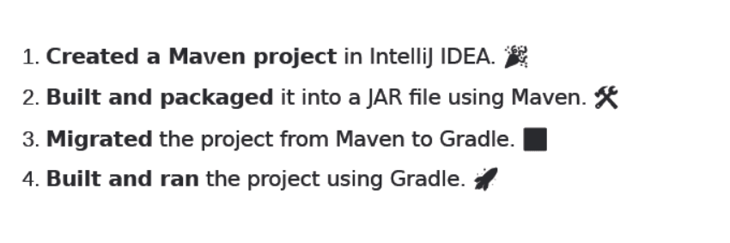

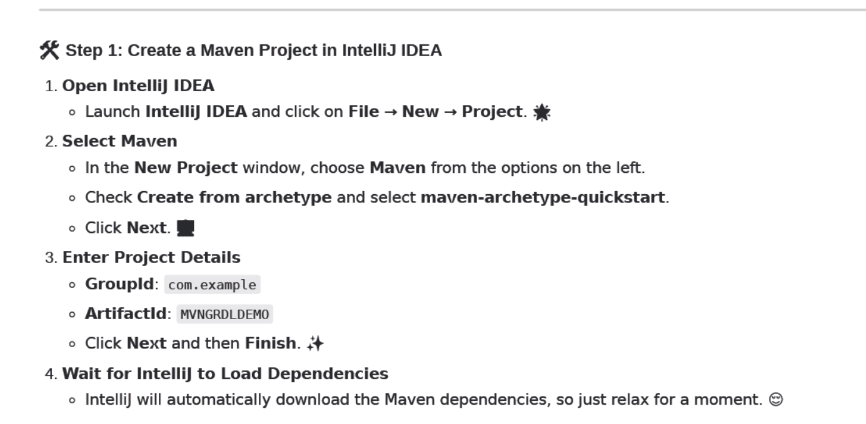

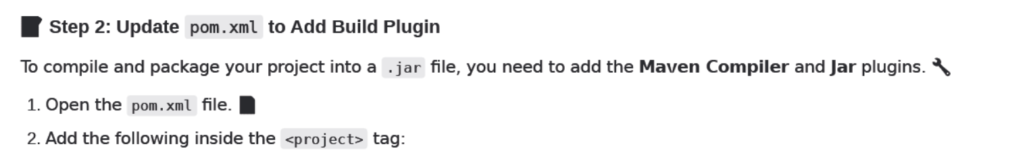

**<build>**

**<plugins>**

**<!-- Compiler Plugin -->**

**<plugin>**

**<groupId>org.apache.maven.plugins</groupId>**

**<artifactId>maven-compiler-plugin</artifactId>**

**<version>3.8.1</version>**

**<configuration>**

**<source>1.8</source>**

**<target>1.8</target>**

**</configuration>**

**</plugin>**

**<!-- Jar Plugin -->**

**<plugin>**

**<groupId>org.apache.maven.plugins</groupId>**

**<artifactId>maven-jar-plugin</artifactId>**

**<version>3.2.0</version>**

**<configuration>**

**<archive>**

**<manifest>**

**<mainClass>com.example.App</mainClass>**

**</manifest>**

**</archive>**

**</configuration>**

**</plugin>**

**</plugins>**

**</build>**

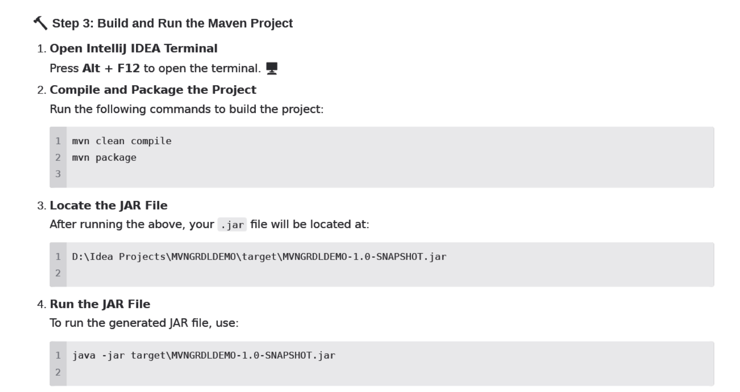

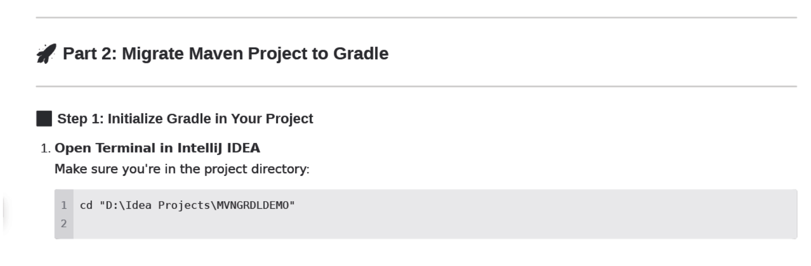

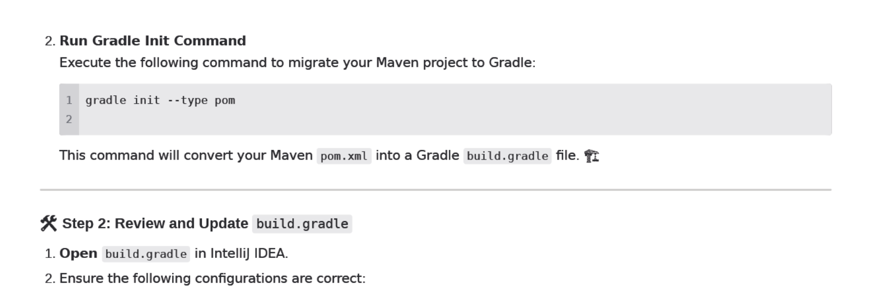

**Copy the below cope in build.gradle**

plugins {

id 'java'

}

group = 'com.example'

version = '1.0-SNAPSHOT'

repositories {

mavenCentral()

}

dependencies {

testImplementation 'junit:junit:4.13.2'

}

jar {

manifest {

attributes(

'Main-Class': 'com.example.App'

)

}

}

